**TABLE OF CONTENTS**

## S. No. CONTENTS Page PO.

* + - 1. **ABSTRACT 04**
      2. **INTRODUCTION 05**
      3. **LITERATURE SURVEY 06**
      4. **REQUIREMENT ANALYSIS 07**
      5. **ARCHITECTURE & DESIGN 12**
      6. **IMPLEMENTATION 17**
      7. **EXPERIMENT RESULTS & ANALYSIS 19**
      8. **CONCLUSION & FUTURE ENHANCEMENT 23**
      9. **REFERENCES 26**

**ABSTRACT**

A private, safe, and secure network is detrimental to an organization’s success. This is because this single entity can enable the transfer of information and effective communication between all the major stakeholders associated with the business. Hence we must ensure quality provision, like features that include speed, reliability, safety, privacy, etc. This project mainly aims to study the architecture of an the network of such an organization. It examines the barriers to planning, designing and implementing such a network. This study also covers the methods to implement level networks. A basic router configuration is used for covering the Routing technologies which route data between branches. After that there is an inclusion of a Wide Area Network (WAN), along with a Frame-relay to connect multiple locations using a single interface of the router. This is not mandatory, but reduces costs. The concept of Network Address Translation (NAT) is of prime importance as we have an active requirement to translate live Internet Protocol (IP) into local addresses for on ground usage, and vice-versa.

# 

# 

# INTRODUCTION

The chosen project aims at building a network configuration suitable for a small business organization. Hence it is important to pay heed to their requirements, after which the design can be improved upon. Priority number one is to have the functional requirements in place. these are requirements that are essential to the business and cannot be compromised upon. The non-functional requirements can then later be added on demand, as these are not essential for the business to run. Their absence may not hinder the company operations drastically.

Implementing a company network scenario is completely dependent on network technologies. Such secured networks are often used in big organizations and other institutions to make secure communication and sharing of their data. We also must have separate networks for departments if each of them is big enough. The main aim is to avoid unauthorized access and maintain data privacy and security with reliable speeds. This is what this project aims to achieve.

# LITERATURE SURVEY

# It is important to pay heed to the company’s requirements, completing which the design can be improved further upon. Priority number one is to have the functional requirements in place. These are requirements that are essential to the business and cannot be compromised upon. The non -functional requirements can then later be added on demand, as these are not essential for the business to run their absence may not hinder the company operations drastically.

# The absolute essential features are listed below:

# A high-speed reliable secure internet connection is essential as it will ensure there are no gaps in communication between stakeholders, and will ensure that the transaction take place in a smooth manner.

# Switches/ethernet hubs help by ensuring all round connectivity so that everything is available to everyone on demand

# Security is also of prime importance as it takes care of two things:

# a) that there is no breach in the ecosystem and that the company data is safe and secure, and not out in the open

# b) that there is no malware/spyware that will jeopardize the company's future performance by corrupting their data assets

# Communication between the organization and the outside world is facilitated by use of a telephone, or other pathways that give the company a specific name or brand value.

# REQUIREMENT ANALYSIS

# In this specific case, the must have features include:

# A secure internet connection -

# The connection with the ISP (internet service provider) should be secure, meaning there shouldn't be any unprecedented breaks in between. this could be detrimental to the business transactions.

# A router with high-speed connectivity capabilities –

# Such a device is essential as it prevents lag and data discrepancy due to time mishaps.

# A modem –

# To provide stable and reliable internet connectivity

# Firewall capabilities -

# This is one of the most important features, as its absence will pose a threat to the company by opening up its confidential data reserves to the public, and hence paving way for a breach

# Multiple Switches -

# This option allows computers to link to each other over an internal network.

# A Phone Line-

# This component can be used for communication with potential customers or other stakeholders

# Security Software-

# To prevent attacks and breaches through malware.

# About the application:

**Cisco Packet Tracer (V8.0.0)**

Cisco Packet Tracer as the name suggests, is a tool built by Cisco. This tool provides a network simulation to practice simple and complex networks.

The main purpose of Cisco Packet Tracer is to help students learn the principles of networking with hands-on experience as well as develop Cisco technology specific skills. Since the protocols are implemented in software only method, this tool cannot replace the hardware Routers or Switches. Interestingly, this tool does not only include Cisco products but also many more networking devices.

**Fig 1.0**

Fig 1.0 shows the Logo for the application

A workspace inside the application looks like this:

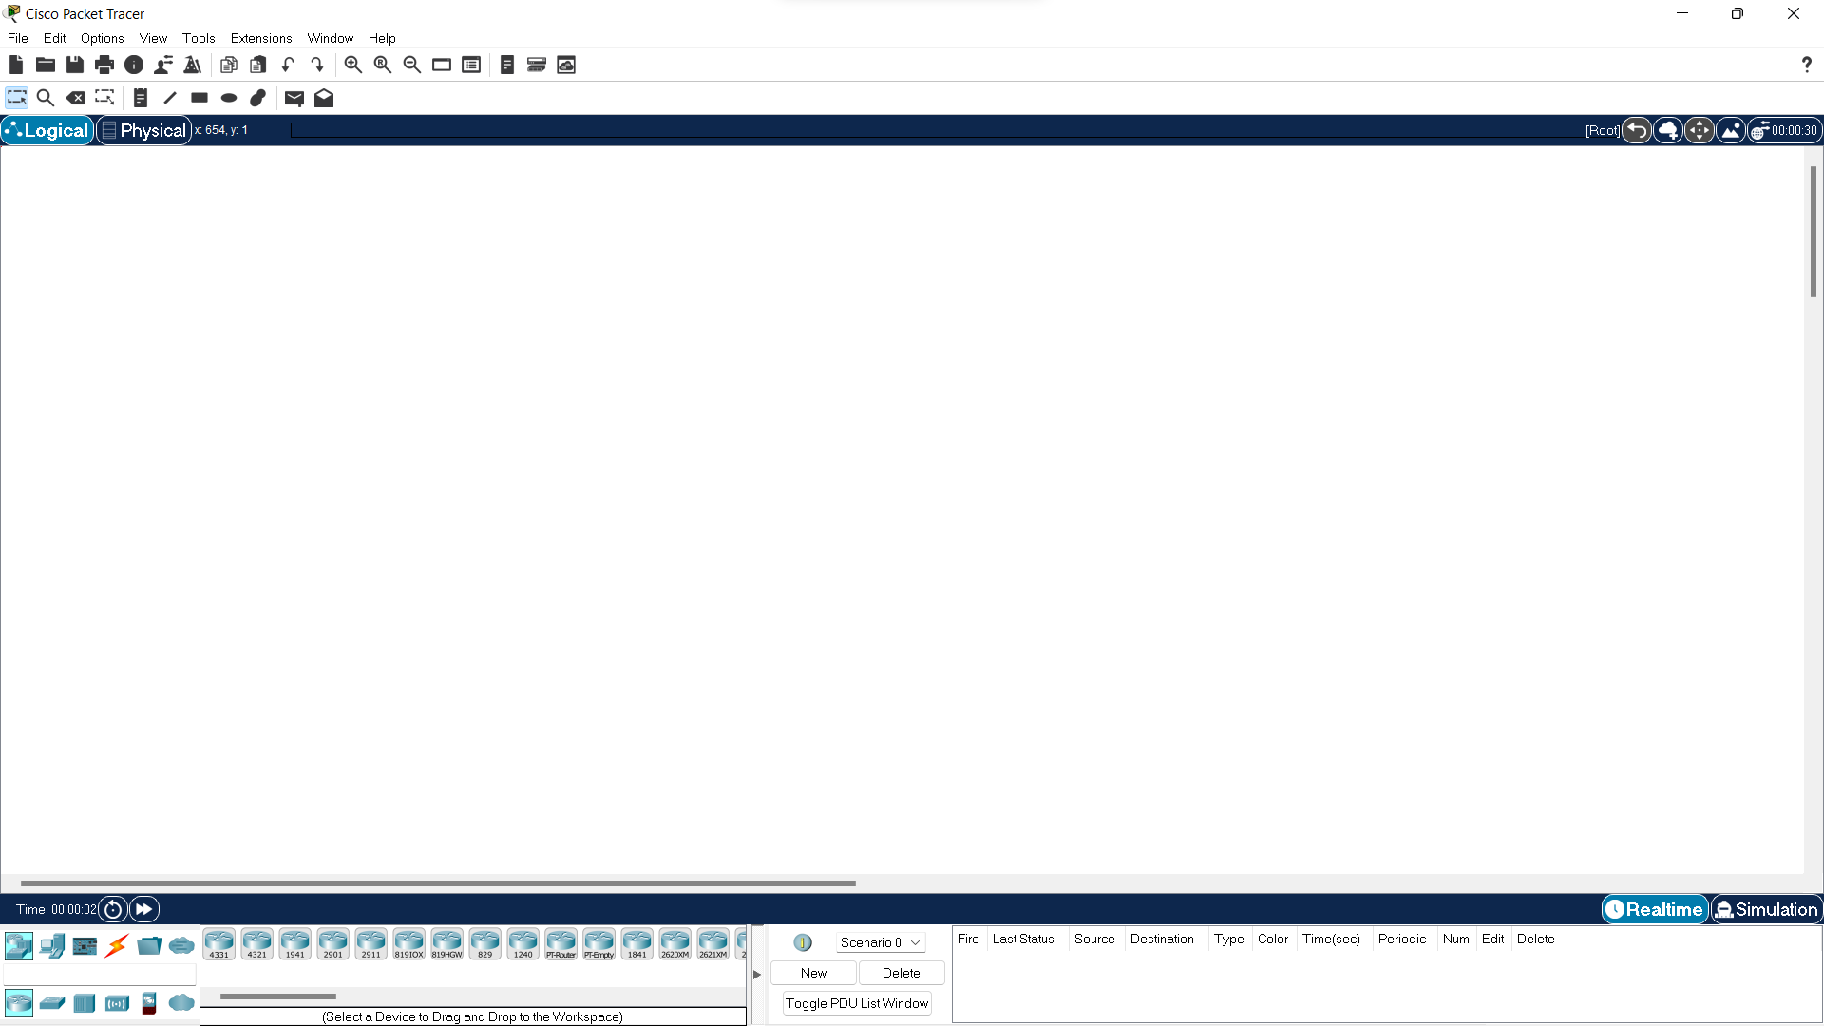

**Fig 1.1**

Fig 1.1 shows a blank workspace inside the application

# Components Involved:

1. **ROUTERS:**

A router is a networking device that forwards data packets between [computer networks.](https://en.wikipedia.org/wiki/Computer_network) Routers perform the traffic directing functions on the [Internet.](https://en.wikipedia.org/wiki/Internet) Data sent through the internet, such as a [web page o](https://en.wikipedia.org/wiki/Web_page)r [email,](https://en.wikipedia.org/wiki/Email) is in the form of data packets. A packet is typically [forwarded](https://en.wikipedia.org/wiki/Packet_forwarding) from one router to another router through the networks that constitute an [internetwork (](https://en.wikipedia.org/wiki/Internetwork)e.g., the Internet) until it reaches its destination [node.](https://en.wikipedia.org/wiki/Node_(networking))

A common tool for modern network computing, routers connect employees to networks, both local and the Internet, where just about every essential business activity takes place. Without routers, we wouldn’t be able to use the Internet to collaborate, communicate, or gather information and learn.

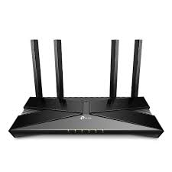

**Fig 1.2**

Fig 1.2 Shows a standard Router

1. **SWITCHES:**

A network switch (also called switching hub, bridging hub, and, by the IEEE,MAC bridge) is networking hardware that connects devices on a computer network by using packet switching [t](https://en.wikipedia.org/wiki/Packet_switching)o receives and forward data to the destination device. A network switch is a multiport network bridge that uses MAC addresses to forward data at the data link layer [(](https://en.wikipedia.org/wiki/Data_link_layer)layer 2) of the OSI model often see them used in home networks or wherever a few more ports are needed, such as at your desk, in a lab, or in a conference room.

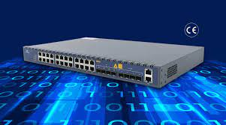

**Fig 1.3**

Fig 1.3 Shows a standard switch

1. **HOST COMPUTER:**

A network host is a computer [o](https://en.wikipedia.org/wiki/Computer)r another device connected to a [computer](https://en.wikipedia.org/wiki/Computer_network) [network.](https://en.wikipedia.org/wiki/Computer_network) A host may work as a server offering information resources, services, and applications to users or other hosts on the network. Hosts are assigned at least one network address.

Hosts typically do not include intermediary network devices like switches and routers, which are instead often categorized as nodes. A node is also a broader term that includes anything connected to a network, while a host requires an IP address. In other words, all hosts are nodes, but network nodes are not hosts unless they require an IP address to function.

**Fig 1.4**

Fig 1.4 shows a regular computer

1. Telephones:

A **telephone** is a [telecommunications](https://en.wikipedia.org/wiki/Telecommunication) device that permits two or more users to conduct a [conversation](https://en.wikipedia.org/wiki/Conversation) when they are too far apart to be easily heard directly. A telephone converts [sound](https://en.wikipedia.org/wiki/Sound), typically and most efficiently the [human voice](https://en.wikipedia.org/wiki/Human_voice), into electronic [signals](https://en.wikipedia.org/wiki/Signal) that are transmitted via [cables](https://en.wikipedia.org/wiki/Electrical_cable) and other communication channels to another telephone which reproduces the sound to the receiving user.

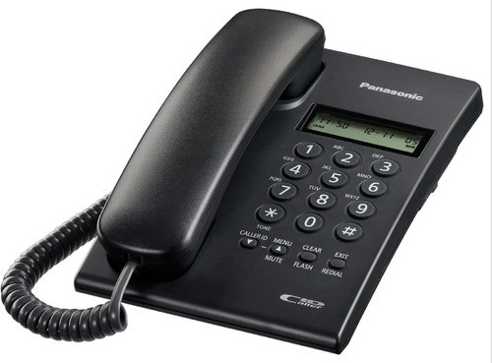

**Fig 1.5**

Fig 1.5 Shows a Telephone

1. **Modems**

A modulator-demodulator or modem is a [computer hardware](https://en.wikipedia.org/wiki/Computer_hardware) device that converts data from a digital format into a format suitable for an analog [transmission medium](https://en.wikipedia.org/wiki/Transmission_medium) such as telephone or radio. A modem transmits data by [modulating](https://en.wikipedia.org/wiki/Modulation#Digital_modulation_methods) one or more [carrier wave](https://en.wikipedia.org/wiki/Carrier_wave) signals to encode [digital information](https://en.wikipedia.org/wiki/Digital_information), while the receiver [demodulates](https://en.wikipedia.org/wiki/Demodulation) the signal to recreate the original digital information. The goal is to produce a [signal](https://en.wikipedia.org/wiki/Signal_(electronics)) that can be transmitted easily and decoded reliably. Modems can be used with almost any means of transmitting analog signals, from [light-emitting diodes](https://en.wikipedia.org/wiki/Light-emitting_diode) to [radio](https://en.wikipedia.org/wiki/Radio). It is the most fundamental device for transmitting internet throughout compact spaces such as offices or homes.

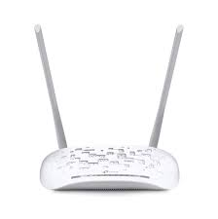

**Fig 1.6**

Fig 1.6 shows a standard modem

# ARCHITECTURE:



**Overview of the entire local system:**

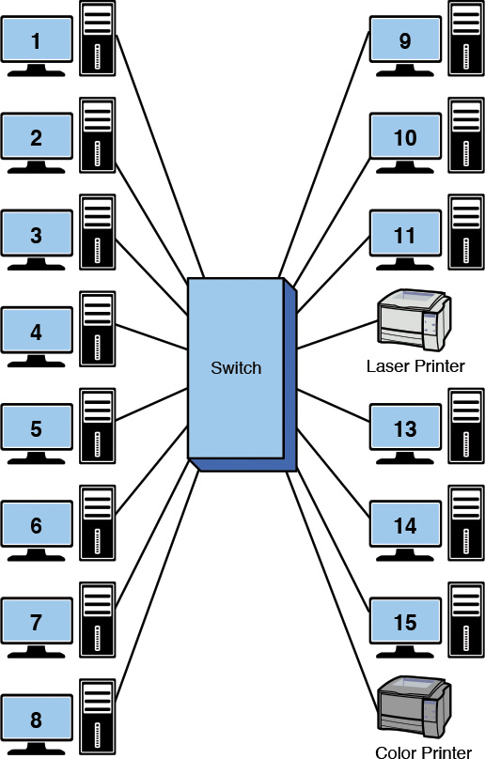

**Fig 1.7**

Fig 1.7 shows a general switch – device configuration

**This is an overview of a basic internet system**

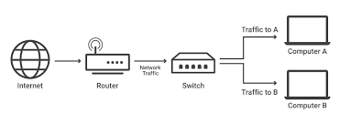

**Fig 1.8**

Fig 1.8 Shows a general system as a whole

# NETWORK DESIGN:

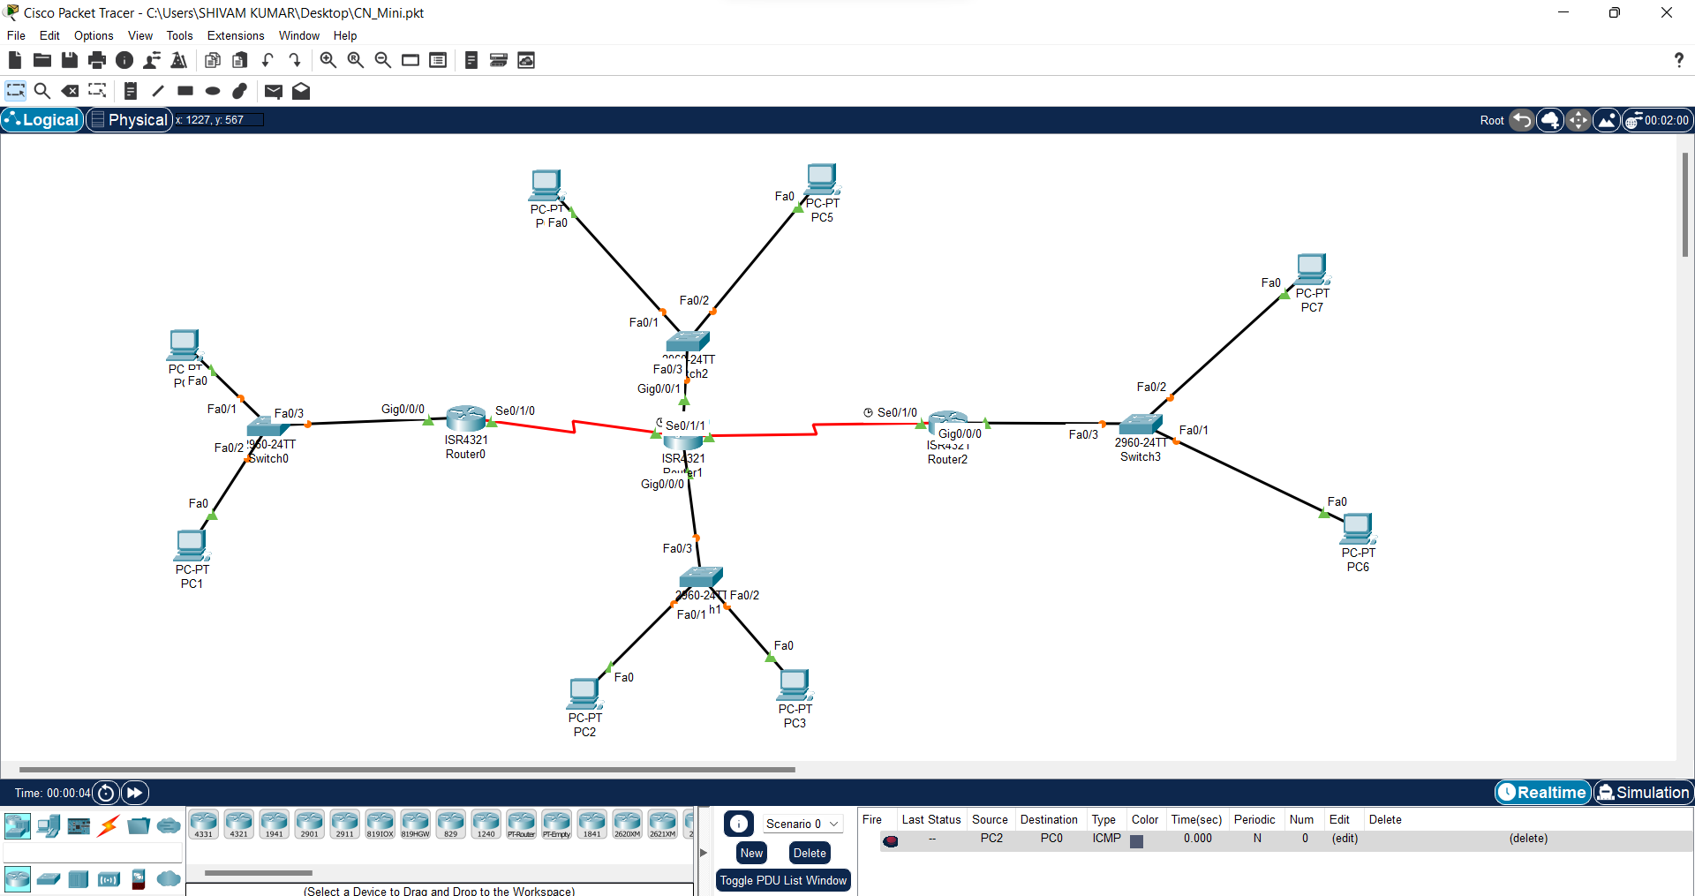

**Fig 1.9**

This figure (Fig 1.9) shows the system that we have built to service our requirements

# IMPLEMENTATION

## IP CONFIGURATION:

## 

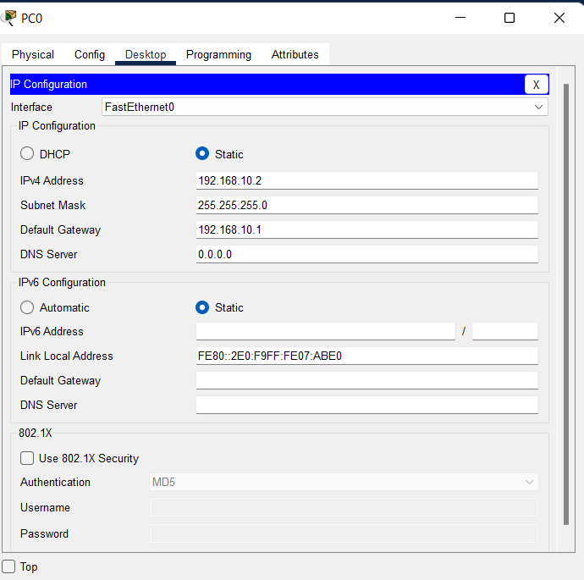

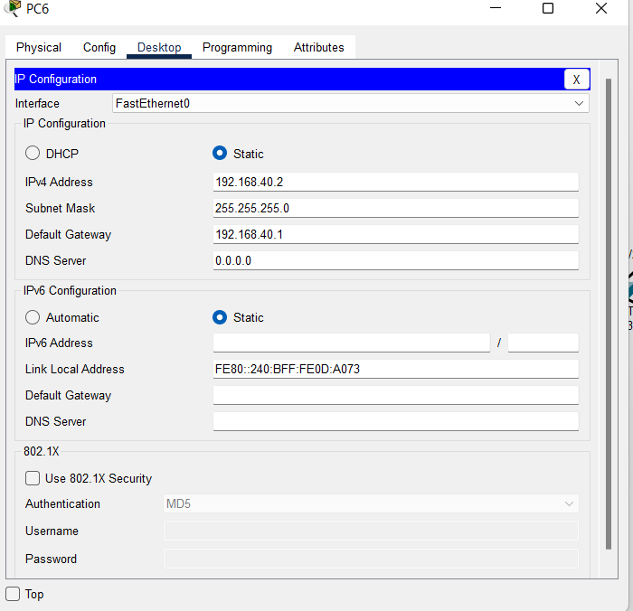

**Ping the PC’s:**

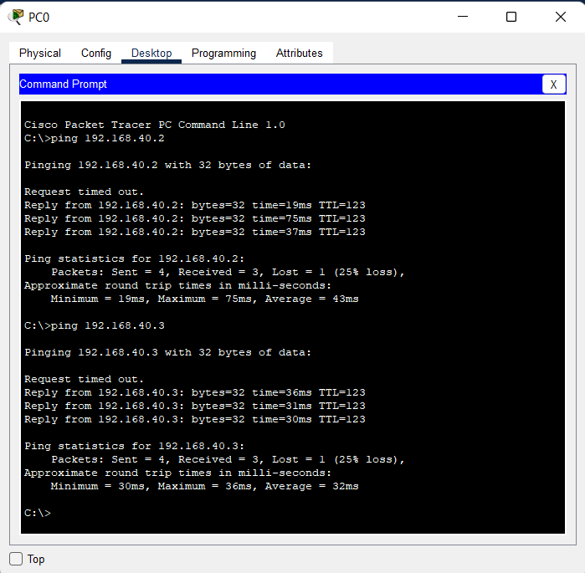

**Protocols Used:**

There are various protocols available for us to use while developing such a system. We can choose a protocol based upon our requirements or main goals. Some of these protocols are:

Transmission Control Protocol (TCP)

File Transfer Protocol (FTP)

Internet Protocol (IP)

User Datagram Protocol (UDP)

Post office Protocol (POP)

Let us say that for this organization, the generation and send out of invoices is of utmost importance. This is because this might be a trading or equity broking company who will have to optimally give the transaction details to their clients, on whose behalf they might be working. In this case, since we are using the system to transfer file type content between the stakeholders, we might want to use file transfer protocol or FTP.

FTP Mainly facilitates communication between a client and a server. FTP servers are the solutions used to facilitate file transfers across the internet. If you send files using FTP, files are either uploaded or downloaded to the FTP server. When you’re uploading files, the files are transferred from a personal computer to the server. When you’re downloaded files, the files are transferred from the server to your personal computer. TCP/IP (Transmission Control Protocol/Internet Protocol), or the language the internet uses to execute commands, is used to transfer files via FTP.

FTP servers can be considered the midpoint between the sender and the recipient of a file. For FTP servers to work, you need the server address. Here’s an example of what this address may look like “ftp.examplecompany.net”. Sometimes, the server address will be given as a numeric address, like “12.345.678.90”.

Depending on the type of FTP server you use and the level of security that is needed, you may have to input a username and password. Some FTP servers allow for anonymous connection, which does not require you to enter a name or password to gain access.

A network host is a [computer o](https://en.wikipedia.org/wiki/Computer)r other device connected to a [computer](https://en.wikipedia.org/wiki/Computer_network) [network.](https://en.wikipedia.org/wiki/Computer_network) A host may work as a [server o](https://en.wikipedia.org/wiki/Server_(computing))ffering information resources, services, and applications to users or other hosts on the network. Hosts are assigned at least one [network address.](https://en.wikipedia.org/wiki/Network_address)

Hosts typically do not include intermediary network devices like switches and routers, which are instead often categorized as nodes. A node is also a broader term that includes anything connected to a network, while a host requires an IP address. In other words, all hosts are nodes, but network nodes are not hosts unless they require an IP address to function.

**Fig 1.10**

Fig 1.10 Shows a general handshake between a client and a server

File transfer protocol is a way to connect two computers to one another in the safest possible way to help transfer files between two or more points. To put it simply, it’s the means by which files are securely shared between parties.

File Transfer Protocol (FTP) is the standard mechanism provided by TCP/IP for copying a file from one host to another.

Although transferring files from one system to another seems simple and straightforward.

Before transferring, some problems must be dealt with first, such as: two systems may use different file name conventions.

Two systems may have different ways to represent text and data. Two systems may have different directory structures.

All of these problems have been solved by FTP in a very simple and elegant approach.

**Fig 1.11**

Fig 1.11 Shows a general FTP Client Server Model

## Client Side Configuration:

`

**Server Side Configuration:**

# IMPLEMENTATION

## IP CONFIGURATION:

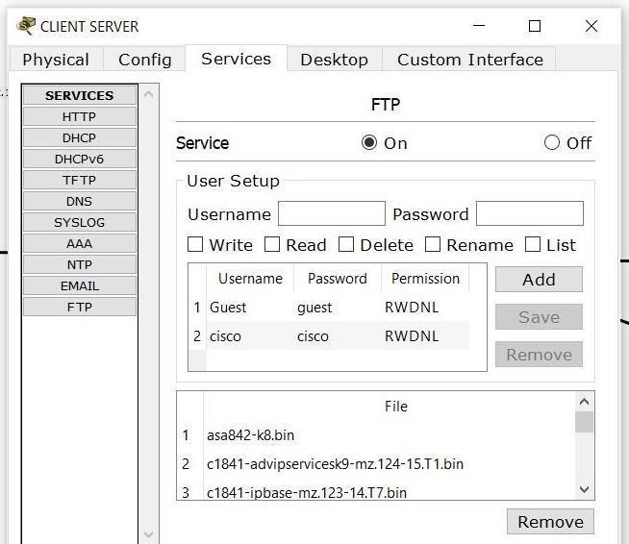

**Pinging the servers -**

## Transferring a file to the server:

## Entering login details and sending a ‘.txt; file to the client server:

**Server Side Get Request -**

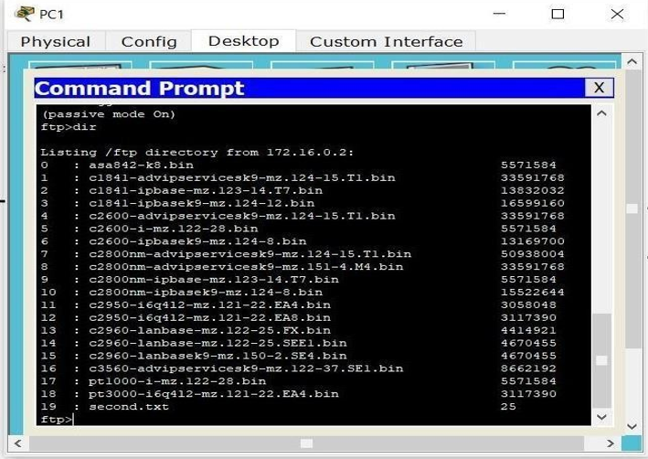

# EXPERIMENT RESULTS & ANALYSIS:

## Result:

The rough network sketch looks as follows:

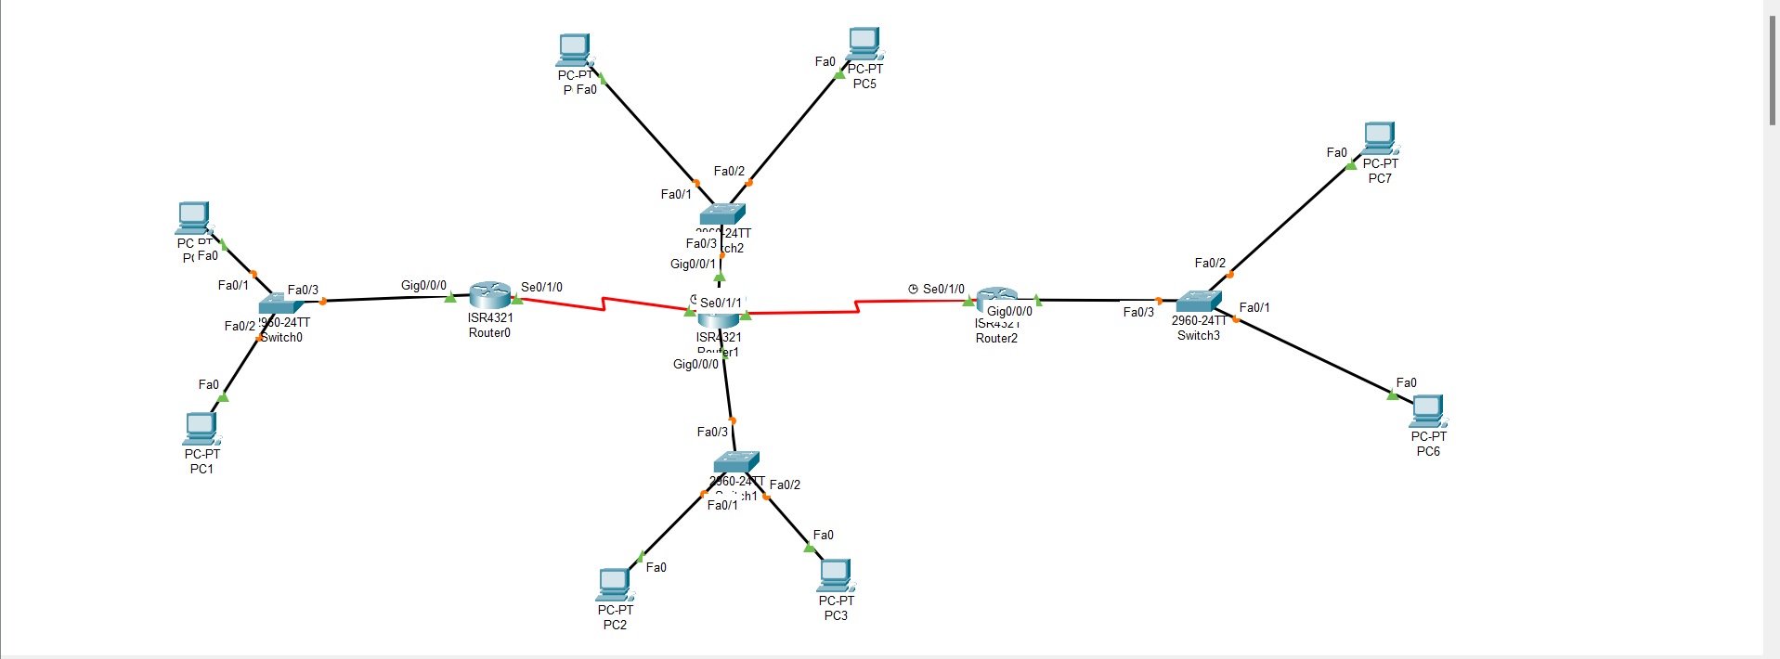

Pinging a computer with data looks as follows:

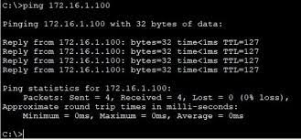

## CONCLUSION

## A network was designed and implemented for a small business company/ organization. The primary goal of this project was to enable communication of data and information between all the stakeholders involved, while giving emphasis on provisional amenities like internet speeds, secure connections, data privacy, prevention of attacks and security breaches, availability of telephone lines, etc. By doing so, we can ensure that the business prospers due to the presence of a reliable system as a whole, to help them with their operations.

## REFERENCES

## https://en.wikipedia.org/wiki/Computer_networks

## https://www.geeksforgeeks.org/basics-computer-networking/

## https://cyberdotin.wordpress.com/2018/05/05/how-do-you-configure-ftpserver-in-packet-tracer/

## www.community.cisco.com www.packettracernetwork.com

## https://www.cisco.com/c/en/us/solutions/small-business/resource-center/networking/how-to-set-up-a-network.html

## https://www.netacad.com/courses/packet-tracer

## https://www.cisco.com/c/en_in/index.html

## https://www.cisco.com/c/en_in/solutions/small-business/networking.html

## https://www.networkworld.com/

## https://www.studytonight.com/computer-networks/ftp-protocol

## https://www.studytonight.com/computer-networks/ftp-protocol